# The Team

Sergey Gavrilchik, Boris Zelikman

# App UI and appearance (How will your app look like)

Feel free to use [this](https://miro.com/templates/aq/ps/templates/wireframe/?utm_source%3Dgoogle%26utm_medium%3Dcpc%26utm_campaign%3DS%7CGOO%7CNB%7CTier2%7CALL-EN%7CCore%26utm_adgroup=%26adgroupid=127668959494%26utm_custom%3D15069324717%26utm_content%3D544877860051%26utm_term%3Dwireframe%20tool%26matchtype=b%26device=c%26location=1007978&gclid=Cj0KCQiAhf2MBhDNARIsAKXU5GQFcPWbYmNrG9cv4gokFFopof0Uv1A0Fq0lG9KLT73-tFupVzoO_DEaAggtEALw_wcB) ui tool.

[wireframepro](https://wireframepro.mockflow.com/)

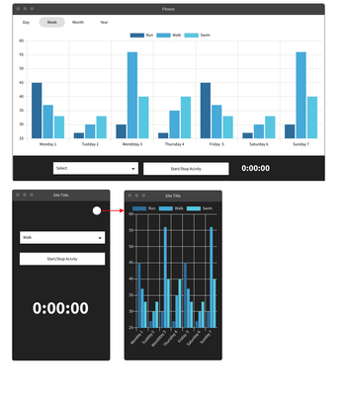

# Product Description (1 sentence)

Our App allows to store time and duration of different kind activities and summarize fitness structure on diagram

Use **\*\*Kanban Template\*\*** and create the following board:

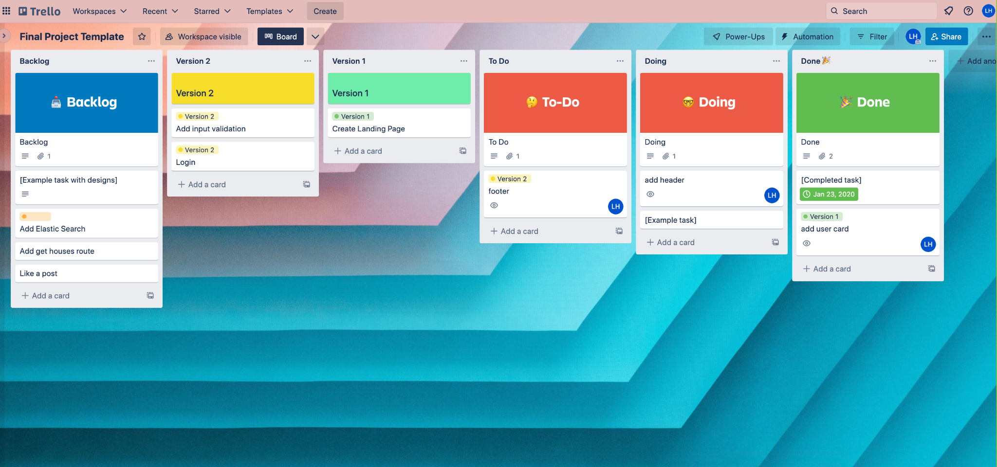

## Version 1 - MVP (the first basic phase of the app)

Include activity kind selector and start/stop button

On Start pressed client sends to server activityKind, server fixes time of strart

On Finish pressed client sends to server finish-command , server fixes time of finish

During activity it is impossible to switch activity kind

## Version 2 (optional, extended version of the app)

Extended search, pagination, login + sign up, sorting, upload houses

## Backlog (Prioritized in a trello kanban)

Favourites, upload houses, feedback, rating

# Database Architecture

House

* A
* b

Host

* A - string
* b

# Project Template

Template for client, server and DB:

<https://github.com/Elevationacademy/full-stack-project-template>

# Server API

Get /houses => [Houses]

Post /houses

# External APIs